### American International University- Bangladesh

**Department of Electrical and Electronic Engineering**

EEE4103: Microprocessor and Embedded Systems Laboratory

***Title:*** Automatic Breaking System Using Arduino Uno.

***Objective:***

Motion detection has been one of the most important fields of research in recent years. Many actions in daily life are carried out in the presence of motion. The usage of Arduino Uno, Ultrasonic sensor, Servo motor, and buzzer to detect and measure distances and break the cars when they are so close to another has been one of the investigation topics. The goal is to detect vehicle distance and emit a beep sound to inform the driver, who will then brake to avoid a collision. The goal of this research was to create a sensor that could simply measure how far away an object is, monitor changes in distance as the object approaches, and display the results in an LED, as well as emit a light coded signal and a beep sound. The Arduino Uno, LEDs, Buzzer, and Ultrasonic sensor were among the components used in Proteus 8.10. The study showed that the designed sensor could be used to accurately determine the position of an approaching object and display the distance readings on the LED. At the same time the sensor displays visual LED signals set and color coded such as for example distances less than or equal to 70 cm The green LED will light up and 40 cm, less than 40 cm the yellow and red LEDs will light up respectively, while beeping from a buzzer. Therefore, this method of distance detection and braking is effective and allows you to avoid accidents.

***Working Procedure:***

An Ultrasonic sensor is placed in front of the vehicle and that setup consists of an emitter and a receiver. Ultrasonic emitter always emits the ultrasonic waves, whenever an obstacle is detected then the wave gets reflected and the receiver receives the signal. A reflected wave sends the signal to the Arduino from that based upon the distance of object it actuates the buzzer or brakes. Brakes are actuated by using a servo motor. It will be operated with a high-power servo motor and brake accurately. This system is designed to solve the problem where drivers may not be able to brake manually exactly at the required time, but the vehicle can still stop automatically by sensing the obstacles to avoid an accident. Ultrasonic sensor will take the input. Depending on the distance the ARDUINO will calculate the input and run the program. Ultrasonic sensor will detect the objects. Ultrasonic ranging and detecting devices will use high-frequency sound waves called ultrasonic waves to detect the presence of an object and its range. If the ultrasonic wave detects the obstacle, it will produce a reflected wave. An ultrasonic receiver will be used for receiving the ultrasonic waves reflected from the road surface to generate a reception signal. If the car is at a safe distance (70cm).The driver will see the green light as an output on the display. The car driver will get a warning (40 cm) by hearing a single buzzer sound and also the yellow light will be on. At last the car will be stopped when the driver hears the buzzer fully beeping and the red light will be on (below 40 cm). Servo motor will activate the braking system and as a result, the car will stop moving. The servo motor allows for precise control of angular position, velocity, and acceleration. It consists of a motor coupled to a sensor for position feedback. Thus, it is a closed-loop mechanism that uses position feedback to control its motion and final position.

***Apparatus:***

1. Arduino Uno board
2. Grove Ultrasonic Ranger, Arduino Buzzer
3. Arduino LED Breakout board
4. Grove servo
5. Grove 128*64 OLED display
6. Proteus 8.10 software

***Simulation Setup:***

Arduino Uno board, Grove Ultrasonic Ranger, Arduino Buzzer, Grove servo, Arduino LED Breakout board, Grove 128 * 64 OLED display is used in Proteus 8.10 software for this auto brake system project. Two ultrasonic sensors were added to measure the distance to the object for three conditions. A red, green, yellow LED, a buzzer, and a servo motor will operate under these conditions. In the SETUP section of the string type variable message, two integer type variables, Dis_1, Dis_2 were declared in an assignment block and the LEDs and buzzer were turned off. Also declare some of the functions using event blocks. We collected all the apparatus from the import project clip.

***Experimental setup:***

A loop was run – First, read the value of four ultrasonic sensors in centimeters using readCentimeters method and show the values in the OLED display by Display_1 subroutine call block and make a 1000 ms time delay. Then we made three conditions in three decision blocks. For the first decision block we set “(Dis_1>=70) && (Dis_2>=70) this condition if the condition is true (YES) then it goes to the Green_on subroutine call block also make a assignment block with a Message of ‘Safe Distance’. After that, in Display_2 a subroutine call block was added to show this result and make a 1000 ms time delay. If this first condition shows false (NO), then it goes to the second decision block with “(Dis_1>=40) && (Dis_1<70) || (Dis_2>=40) && (Dis_2<70) this condition. If this condition is true (YES) then it goes to Yellow_on subroutine call block, creating a Message ‘Closer Distance Alert’ in an assignment block. After that show this message in Display_2 and add 1000 ms time delay. If this condition also false (NO) then it goes to the last decision block with “(Dis_1<40) || (Dis_2<40) this condition. When this condition shows true (YES) then it goes to the Red_Buzzer_on subroutine call block, creates an assignment block with ‘Automatic Braking System Activated’ message, and then shows the result is Display_2 with 1000 ms time delay. After this portion servo will be activated for braking. Finally, all of these three conditions go END of the loop.

***Results and Discussion:*** This device can task based on three conditions mainly. The OLED display shows the distance of the four sides (Front, back) which are measured by ultrasonic ranger. For the first condition when all of the four-sensor distance value is equal or more than 70cm (27.5591 inch or 2.29 feet) then the green LED will be turn on and “Safe Distance” message will show on the display. Then for the second condition if any one of the sensors measure the distance less than 70cm (27.5591 inch or 2.29 feet) and equal or more than 40cm (15.7inch).

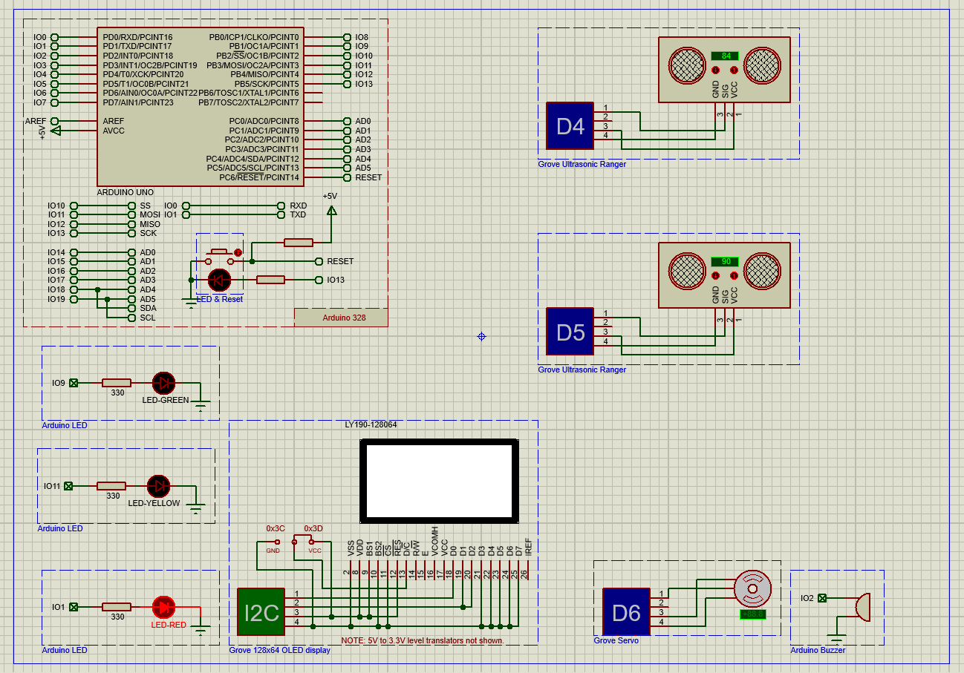

Figure 1: Schematic capture in Proteus 8.10

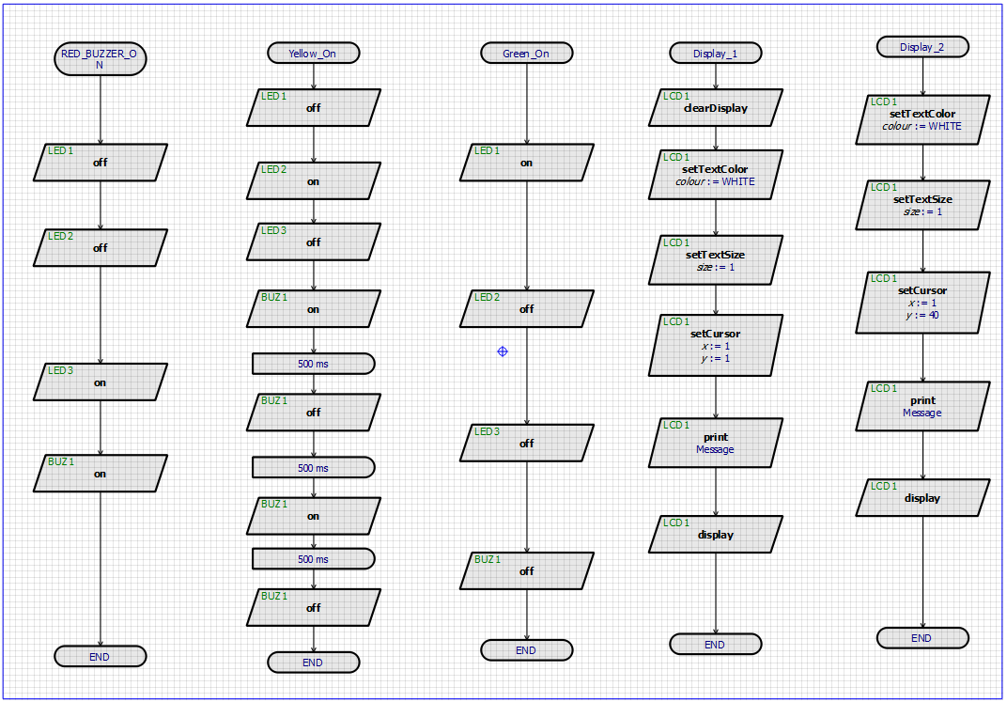

Figure 5: Implementation of flow chart in Visual Designer (Part-1)

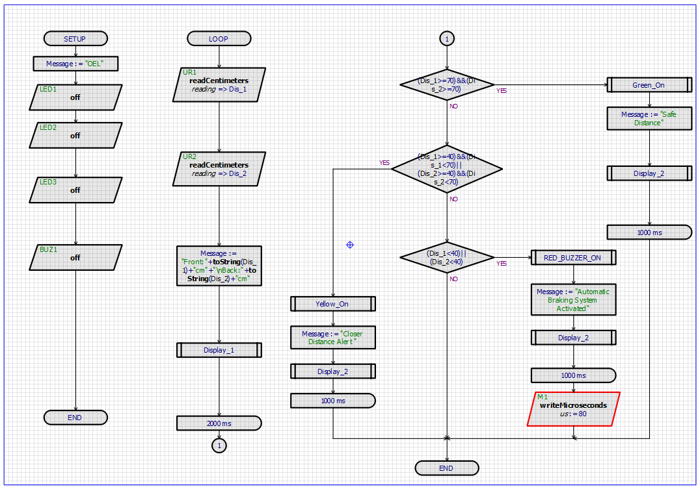

Figure 3: Implementation of flow chart in Visual Designer (Part -2)

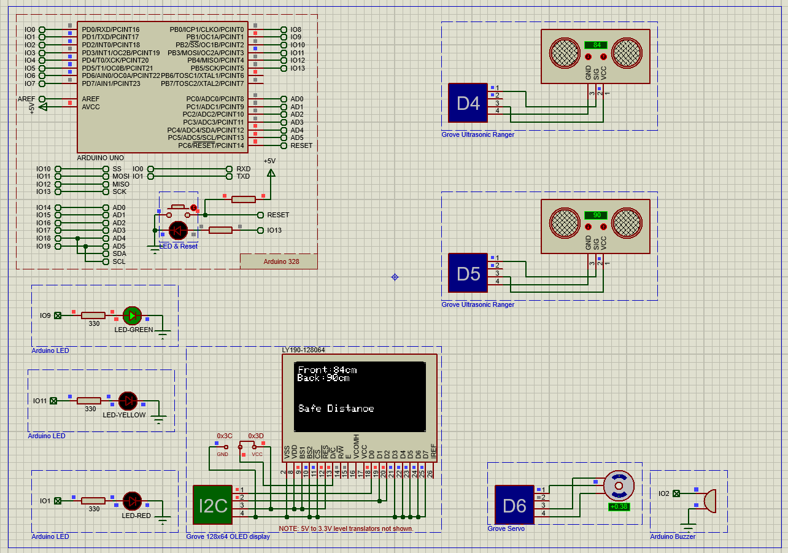

Figure 4: Green LED on and “Safe Distance” message show on display

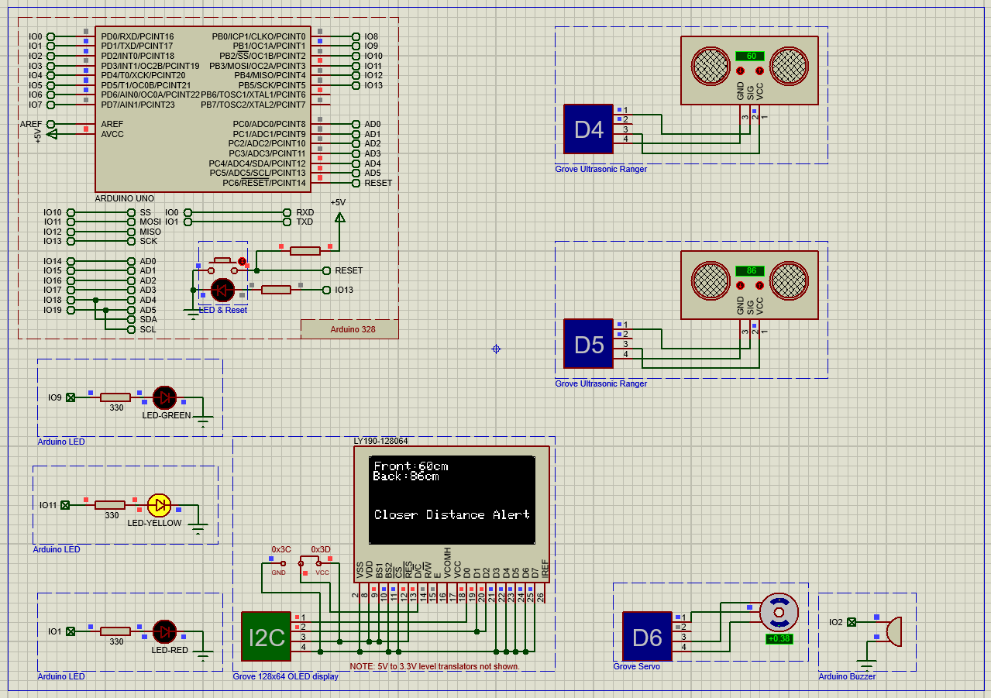

Figure 5: Yellow LED on and “Closer Distance Alert” message show on display

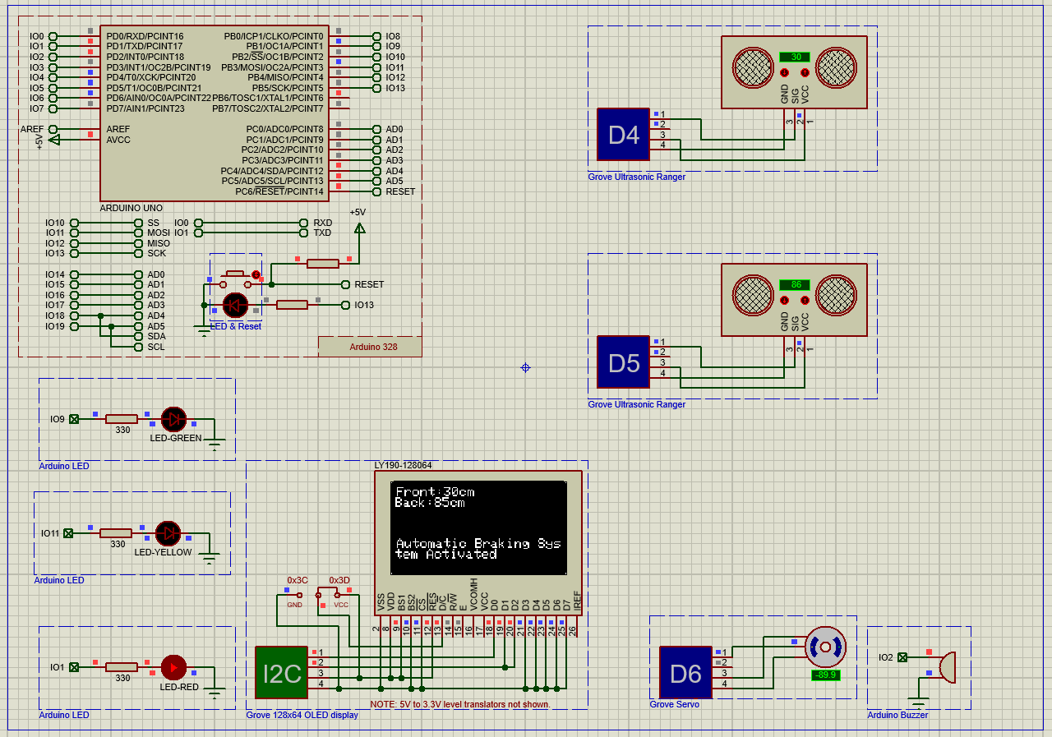

Figure 7: Red LED on, servo motor at (-89.9)-degree, buzzer on and “Automatic Braking System Activated”” message show on display

***Discussions:***

This experiment let us to create a Automatic Breaking System Using Arduino uno in proteus. In schematic capture Grove ultrasonic ranger used for sense the distance and Grove servo used for braking system. If the distance is greater than 70cm light will be green, if the distance is between 40cm to 70cm yellow light will be turn on also shown an alert message and if the distance is less than 40cm red buzzer turn on and braking system will work automatically. We implement the method in proteus in visual designer using flowchart and used necessary attributes to create the design. Then in schematic capture necessary equipment was placed from apparatus section and the simulation was run and the result can be seen.